- Prescrictive analysis

This section seeks to anticipate what could happened in a short term in topics related with the gold, Crude Oil and BTC and how these movements are reflected in the current geopolitical tensions and the changes in the international financial balance.

The goal is to identify trends directions that help understand how the markets are responding to the way the dollar loss power and the global economic fragmentation growing.
- Methodological approach

Based on the applied and exploratory nature of the study, simple moving averages of three months applied to actual monthly data are used to project trends up to the first quarter of 2026 through the following analyzed variables:
- Gold imports of BRICS’s countries (quantity and value)
- Crude Oil imports of BRICS’s countries (quantity and value)
- BTC Trading volume dominated in USA

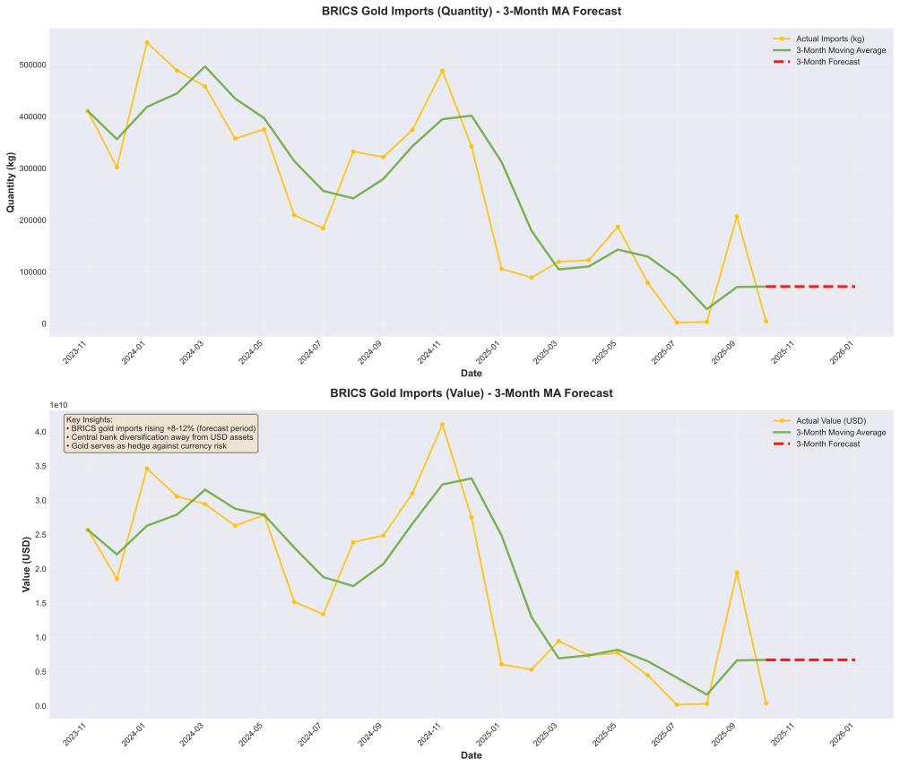
- Gold accumulation as a defensive strategy

Figure 1. Gold BRICS forecast

Data shows that after a slowdown of gold imports during 2024 and 2025, the 3-month moving average resurgence in gold accumulation by the BRICS countries, The projection suggest growing of approximately 8% and 12%.
This behavior is consistent with the use of gold as a defensive asset against risk of financial sanctions, potential freeze of foreign currency reserves and reduce dependence on dollar denominated assets.

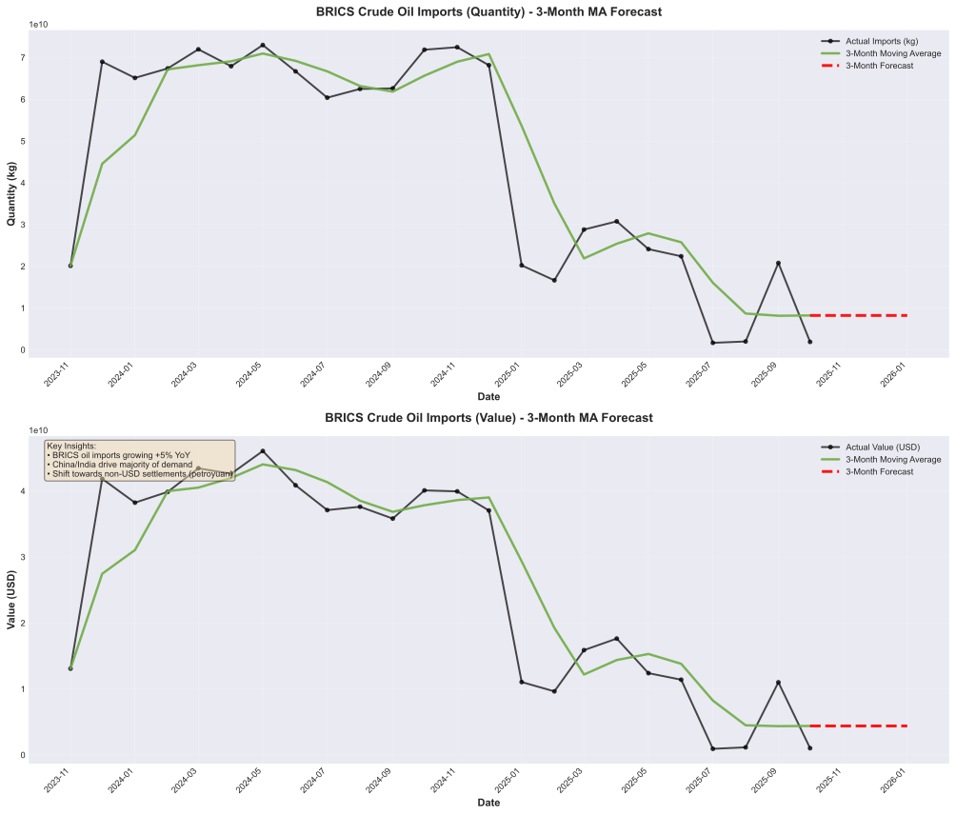
- Crude Oil, a geopolitical hedge

Figure 2. BRICS Crude Oil Imports
The predictive analysis of Crude Oil indicated a continuous and moderated grown on imports by BRICS with an increase of 5% year over year driven by majority by China and India.
Beyond physical volumes, the strategic value of crude oil lies on its role as a geopolitical instrument and increasingly energy trade is linked to bilateral agreements, alternative currencies to the dollar and settlement mechanisms outside the traditional financial system.
From this perspective, the crude oil does not act as a monetary safe haven comparable to gold but rather as a transactional hedge used to cover risks associated to international trade and energetic security.
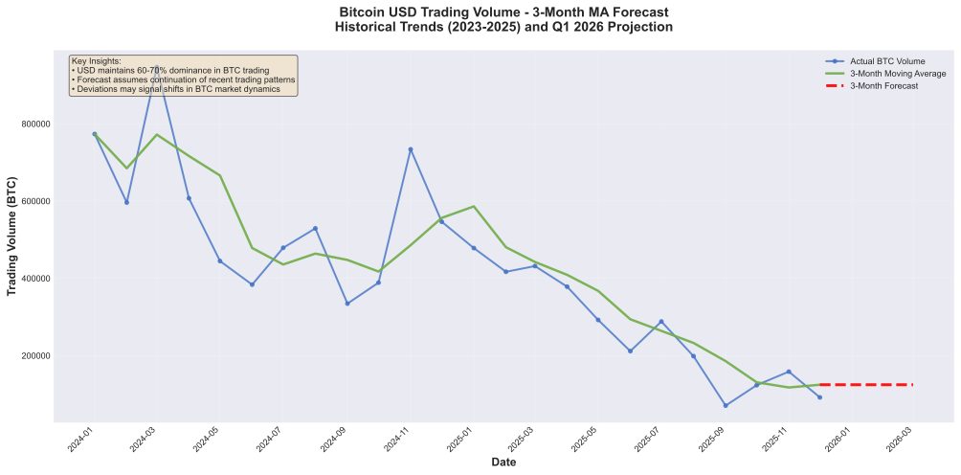
- Bitcoin: Financial stress thermomether

Figure 3. Bitcoin USD Trading Volume

In the case of Bitcoin, the analysis focuses on trading volume dominated in USD, rather than price, the data show that although the dollar still accounts for between 60% and 70% of the volume, its dominance is lowering in the long term.
The projection thought moving average suggest a short-term stabilization, although any significant deviation from this trend could be interpreted as an early sign of regulatory changes, macroeconomic shocks or a loss of confidence on the dominant monetary system.
In this context, Bitcoin does not behave as a safe haven but rather as a fast indicator of tension and financial transition, reacting before the traditional assets.

- Comparative forecast analysis – 3-months prediction
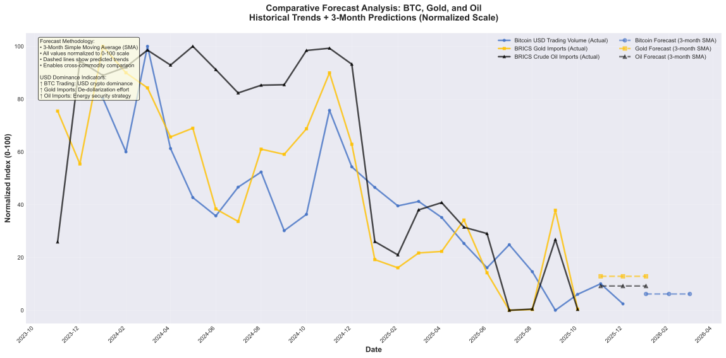
Figure 4. Comparative forecast analysis: Historical Trends and 3-months prediction
The comparison between Gol, Crude Oil and Bitcoin revels a differentiated response to global tensions.
- Gold acts as a long-term strategic reserve.
- Crude Oil serves as trade and geopolitical hedge.
- Bitcoin function as a high-sensor frequency of financial stress.
The predictive analysis suggests that, if current tension persist, these three assets won’t complete with each other, but will continue to fulfill complementary roles within the global financial system.
7. Practicals implications
For BRICS countries the forecast show:
- The projection suggest gold accumulation will continue in the short-term, reinforcing its role as a hedge against monetary and geopolitical risk.

- The crude oil forecast points to contained but persistent growth, consistent with energy security strategy rather than financial safe haven dynamics.

- In the bitcoin forecast suggest a stabilization of USD denominated volume indicating possible gradual transition rather than an immediate replacement of the dollar.

Conclusion
The predictive analysis shows that geopolitical tensions and the changes in global financial power are already influencing the behavior of gold, the oil and bitcoin.
While gold consolidates its role as an strategic reserve, oil reinforce its geopolitical dimension and bitcoin emerges as an early indicator of monetary transition rather than a safe haven.

